 |  | WYNNUM TABLE TENNIS ASSOCIATION
 |  | 2020 Open Tournament
 |  | 14th & 15th March 2020
Venue: |  | Wynnum Table Tennis Centre  38 Curtis Street, Manly, QLD 4179
Entries Close: |  | Wednesday 11 March 2020
Please note that entries will only be accepted via the online entry form: https://www.wynnumtabletennis.org.au/events
2020 WYNNUM OPEN REGISTRATION

(Ctrl + click to follow the above link – a reply confirming receipt will be sent within 48 hours)
Payment: |  | Payment is required upon arrival (cash and card accepted)
Enquiries: |  | Franck Roguiez
Phone: |  | 0426 275 807
Referee: |  | William Almasi
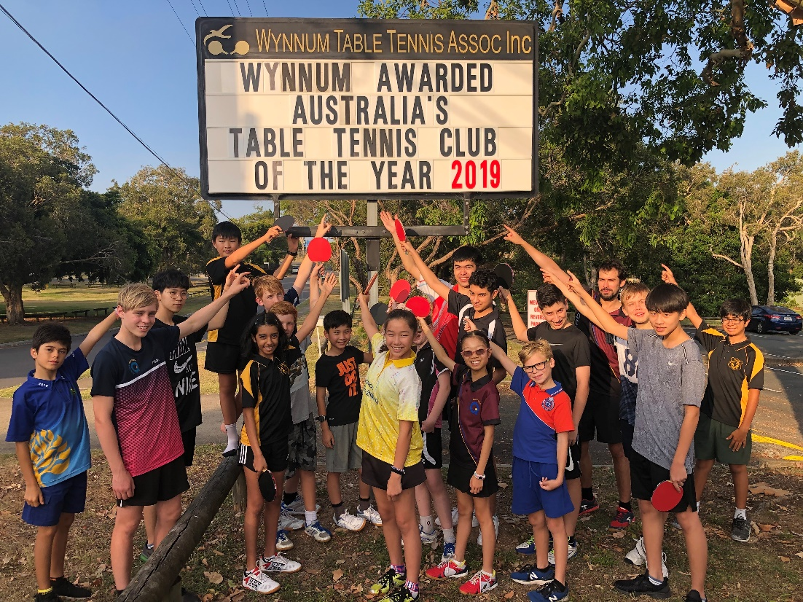
2020 WYNNUM OPEN – EVENTS & ENTRY COSTS

Saturday 14th March 2020 |  |  | Sunday 15th March 2020
1 | Men Open Singles | $15 | 17 | < 800 Singles | $10
2 | Women Open Singles | $15 | 18 | < 1000 Singles | $10
3 | Men Open Doubles | $10 each | 19 | < 1000 Doubles | $8 each
4 | Women Open Doubles | $10 each | 20 | < 1200 Singles | $10
5 | Mixed Open Doubles | $10 each | 21 | < 1200 Doubles | $8 each
6 | < 1800 Singles | $10 | 22 | < 1400 Singles | $10
7 | < 1600 Singles | $10 | 23 | < 1400 Doubles | $8 each
8 | Over 40 Singles | $10 | 24 | Over 50 Men | $10
9 | Over 40 Women Singles | $8 | 25 | Over 50 Women | $10
10 | Under 11 Singles | $5 | 26 | Over 60 Men | $10
11 | Under 13 Boys Singles | $8 | 27 | Over 60 Women | $10
12 | Under 13 Girls Singles | $8 | 28 | Over 70 Men | $10
13 | Under 15 Singles | $8 | 29 | Over 70 Women | $10
14 | Under 18 Boys Singles | $8
15 | Under 18 Girls Singles | $8
16 | Under 21 Singles | $8
 |  |  |  | TTQ Player Development Levy | $2

**A TTQ Player Development levy of $2.00 will also be payable in addition to event costs.
This levy is applied once per person for this tournament.**
Prize Money
- Men’s & Women’s Open Singles: $300 Winner, $150 Runner-up,
$75 Losing Semi-Finalists

- < 1800 Singles: $140 Winner, $70 Runner-up, Semi-Finalist $30

- All other events: 40% of Event Entry Fees to Winner and 20% to Runner-up if 8 or more players/pairs participate. In an event where less than 8 players/pairs have entered, the event may be cancelled or only the winners receive prize money. Prize money in these events is subject to change depending upon entries.
2020 WYNNUM OPEN – TOURNAMENT CONDITIONS
(Lodgement of an entry will be considered as acceptance of these conditions)
- With exceptions provided by these conditions, the tournament will be held under TTQ and ITTF rules and regulations
- All entrants must be appropriately registered players of an Association affiliated with TTQ and/or TTA.
- Matches in the quarter-finals, semi-finals and finals of the two Open singles events are the best of seven, 11-point games. All other matches are the best of five, 11-point games.
- Subject to the number of entries, ‘Round-Robins’ may be played.
- Late entries may be accepted at the discretion of the Tournament committee.
- Closing Date: midnight Wednesday 11 March 2020
- The decision of the Referee will be final on a point of law. An umpire whose decision will be final on a point of fact shall control each match.
- All seedings, gradings and acceptance of entries are at the discretion of the Tournament Committee, using ratingscentral.com as a reference. Grading for Doubles events will be based on the average rating of the players.
- All players are expected to be available to umpire matches.
- Players not available to play when called upon will be liable to disqualification.
- Players participate at their own risk and no claim for injury will be recognised.
- Any event with fewer than four entries may, at the discretion of the Tournament Committee, be cancelled or combined with another event without prior notification.
- Players may enter any event for which they are eligible, although players cannot enter more than one event starting at a specific time.
- Doubles players must ensure that their partner has submitted a separate entry form. If a partner is required, write “PARTNER REQUIRED” in the space provided.
- Entry fees are to be paid by cash or via EFTPOS on the day.
- Bad language, offensive or unsportsmanlike behaviour or wilful damage will not be tolerated; offenders will be liable to disqualification and the cost of necessary repairs.
- Dress regulations will be enforced including non-marking shoes. During play, caps, other head wear or accessories may only be worn with the permission of a Referee.
- AGE LIMITS: Over 30, 40, 50, 60 and 70 during 2020.
- Under 11, 13, 15, 18 and 21 as at 1 January 2020.
- All players are required to report to the registration window on arrival on each day they are registered for events, at least 15 minutes prior to the scheduled starting time of the first event.
- Starting times are approximate and may be adjusted.
- The tournament committee reserves the right to alter starting times of events.
- It is the responsibility of each player to ensure that racket coverings are attached to their racket blade with adhesives that do not contain harmful volatile solvents. Neither gluing nor re-gluing of rackets is permitted inside the playing hall.
- DHS 3 Star 40+ Table Tennis Balls (white) will be used. The colour of shirts, shorts and skirts shall be clearly different in colour to the ball.

2020 WYNNUM OPEN – EVENT TIMETABLE

Saturday 14 March |  | Sunday 15 March
8:30 | U11 Singles,  U18 Boys Singles,  U18 Girls Singles | 8:30 | <1000 Doubles,  <1200 Doubles,  <1400 Doubles
10:00 | U13 Boys Singles,  U13 Girls Singles  U21 Singles | 10:00 | <1000 Singles
 |  | 10:30 | <1400 Singles
11:00 | O40 Men Singles,  O40 Women Singles | 11:00 | <800 Singles
11:30 | U15 Singles,  Mixed Open Doubles | 11:30 | O60 Men Singles  O60 Women Singles
 |  | 12:00 | <1200 Singles
13:00 | <1800 Singles | 13:00 | O50 Men Singles,  O50 Women Singles
14:00 | Men Open Doubles,  Women Open Doubles | 14:00 | O70 Men Singles,  O70 Women Singles
15:00 | Men Open Singles,  Women Open Singles | 15:00
16:00 | <1600 Singles,

Entries
Follow the link below to register online:
https://www.wynnumtabletennis.org.au/events

2020 WYNNUM OPEN REGISTRATION
(Ctrl + click to follow the above link – a reply confirming receipt will be sent within 48 hours)

